N = 17 wave imaging trials in seven retina pieces from five mice
Start by fitting a double exponential to detrend the data. If the double exponential cannot fit, exclude (three trials excluded).
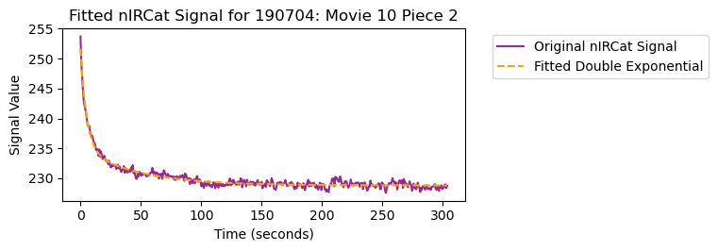
Find retinal waves by peak detection on the cal520 signal:
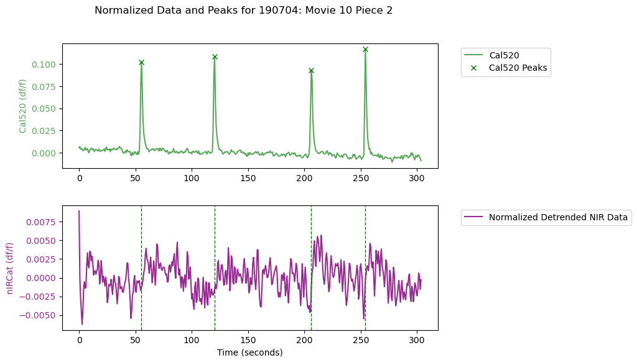

Then construct wave-triggered averages. To compare wave-triggered nIRCat signal to random fluctuations, shuffle the data (n=100 shuffles of k = (number of actual waves) random trigger frames). Measure average of three frames around peak of nIRCat signal in the 10 second pre- and post-wave peak windows.
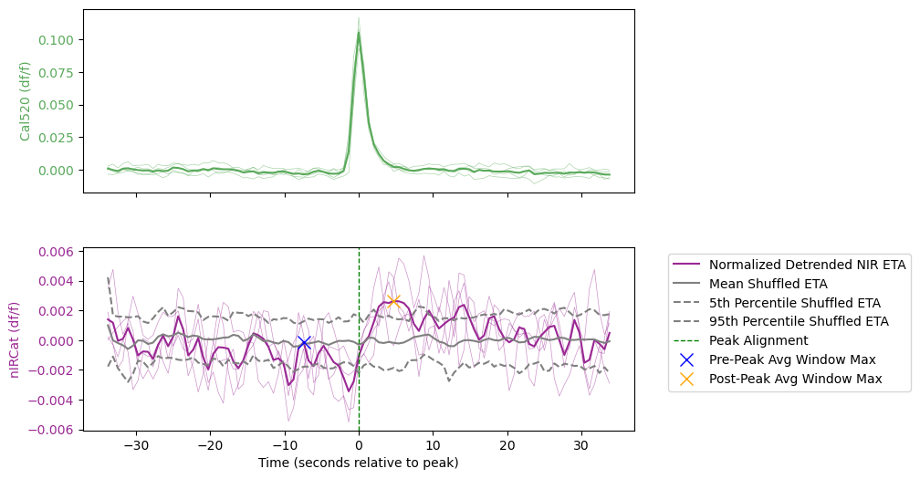

I defined a ‘significant response’ as at least three consecutive movie frames post-wave where the wave-triggered mean nIRCat signal exceeds the 95th percentile of the shuffled data. This yields just two significant responses: 190704 movie 10 piece 2, pictured above, and 190711 movie 9 piece 3 (in nomifensine) pictured below.

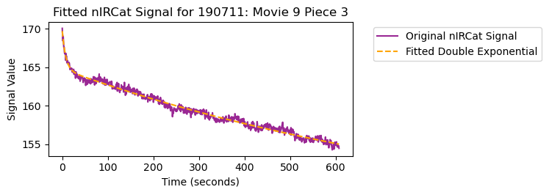
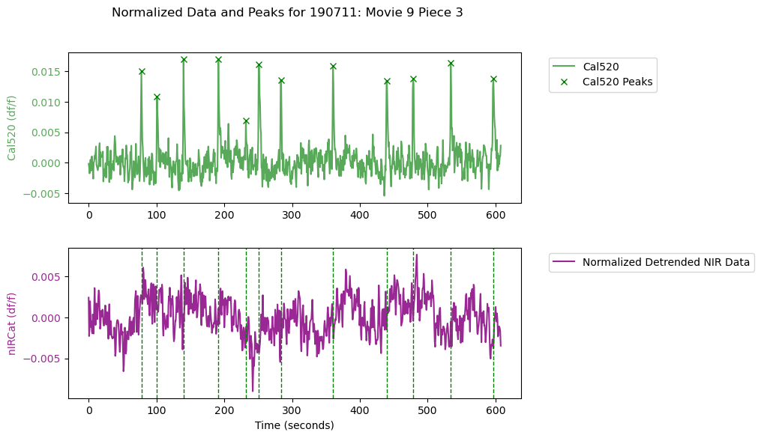
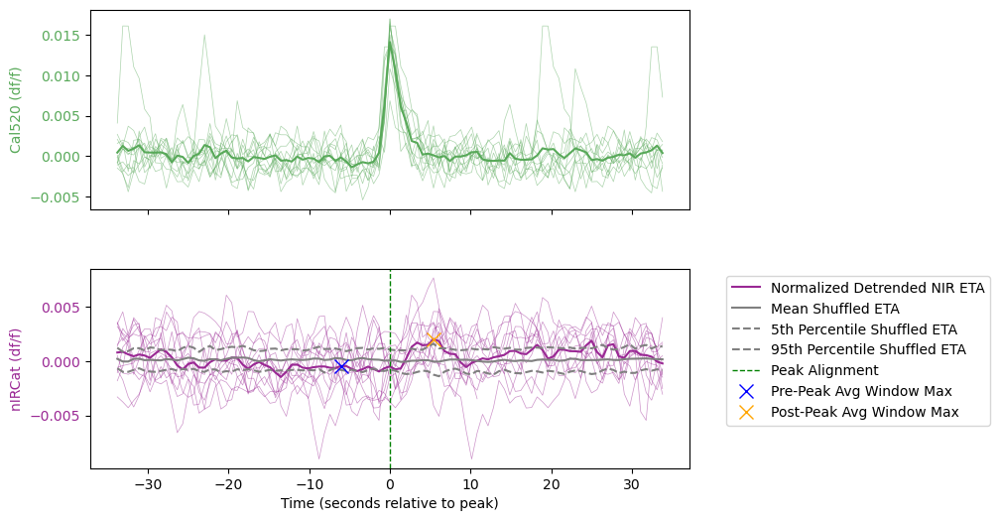

Despite the low rate of significant responses (just 2/17 trials in 2/5 mice), I also analyzed the data on aggregate.

This plot compares the mean wave-triggered nIRCat fluorescence measurements before and after the wave peaks. 190703 movie 1 piece 1 (the blue x) is a negative control using the SWCNT without the single stranded DNA that makes them sensitive to dopamine.
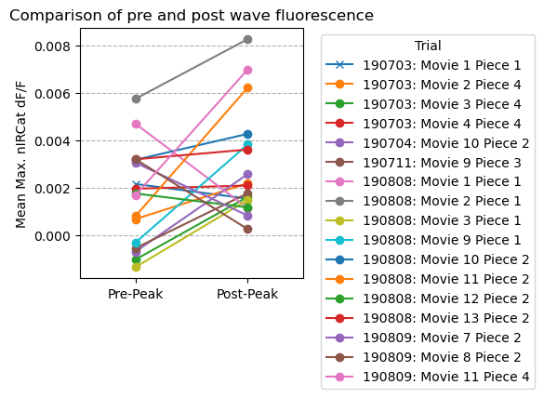
Here are the differences, computed directly from the plot above:
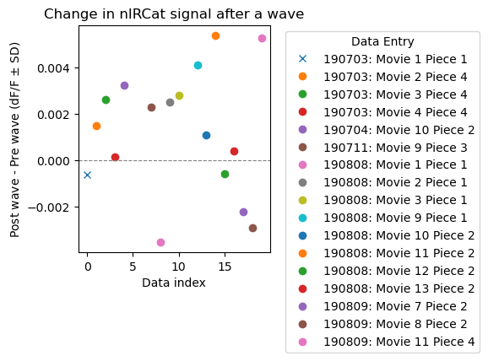

Data aggregated by retina piece, excluding the negative control:
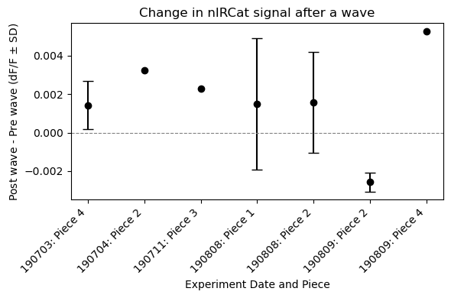

Same as above, but collapsed into a single distribution:
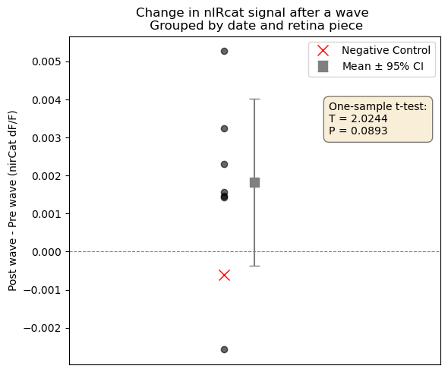

Finally, the data aggregated by animal. Statistically significant!
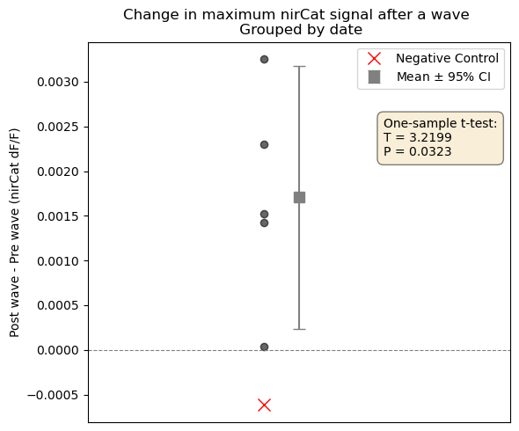

I will share the analysis code and data as a Github repository. Once you download the repository, open the python notebook, change the ‘basepath’ at the top of the notebook to the location of the repository on your computer, and run the notebook. Ensure you have all the modules installed in your python environment. This should reproduce all the analysis shown here and make plots of the traces for every trial.
You can also perform your own analyses on the csv data files in the ‘waves’ subfolder and make sense of the data by inspecting the ‘dopamine imaging.csv’ file that provides metadata for each trial.

